P.Sesha Harshini

1NT19IS107

C1 BATCH (12-04-2022)

1.Updating many values using set.

db.names.updateMany({name:"Teja"},{$set: {"age":"21","Place":"Banglore"}},{multi:true})

db.names.find()

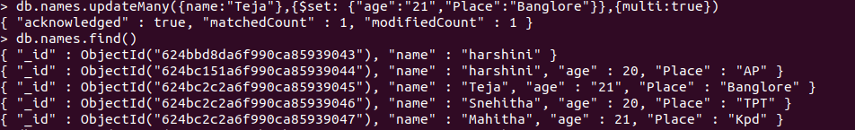

Deleting one field using unset.

db.names.updateOne({"name":"Mahitha"},{$unset:{"Place":" "}})

db.names.find()

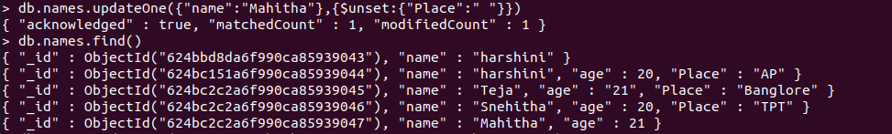

Adding the deleted field

db.names.updateOne({"name":"Mahitha"},{$set:{"Place":"Chennai "}}

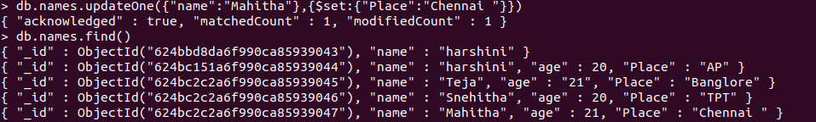

Deleting many fields using unset

db.names.updateMany({"name":"harshini"},{$unset:{"age":"","Place":""}})

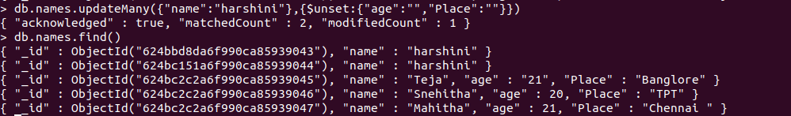

Deleting one tuple.

> db.names.deleteOne({"name":"harshini"})

db.names.find()

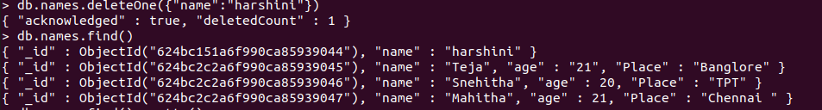

Adding the deleted tuple

db.names.updateMany({"name":"harshini"},{$set:{"age":20,"Place":"Delhi"}})

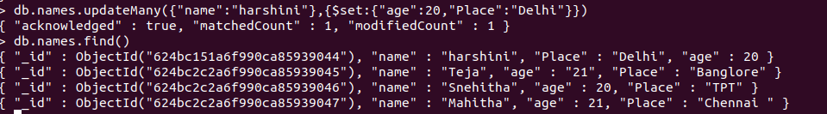

Deleting many tuples

db.names.deleteMany({"name":"harshini"})

If there are duplicate values then those tuples are deleted.

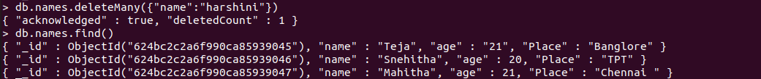

db.names.find({$and:[{"age":{$gte:19}},{"Place":"TPT"}]}).pretty();

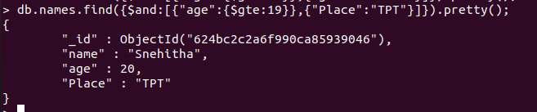

db.names.find({$or:[{"age":{$gte:19}},{"Place":"TPT"}]}).pretty();

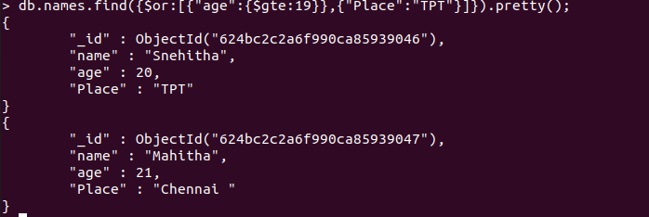

> db.names.replaceOne({"name":"Snehitha"},{"name":"Indu"})

Before replacing:



After replacing:

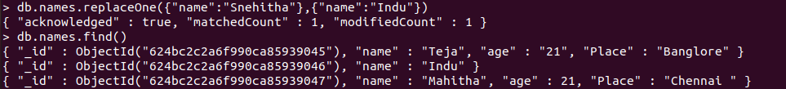

Changing the replaced tuple

db.names.updateMany({"name":"Indu"},{$set:{"age":"20","Place":"TPT"}})

